7.b) Implement form validation and error handling.

import 'package:flutter/material.dart';

void main() {
runApp(const MyApp());
}

/// Main app starting point
class MyApp extends StatelessWidget {
const MyApp({Key? key}) : super(key: key);

@override
Widget build(BuildContext context) {
return MaterialApp(
title: 'Form Validation Demo',
debugShowCheckedModeBanner: false,
theme: ThemeData(primarySwatch: Colors.teal),
home: const LoginFormScreen(),
);
}
}

/// Stateful widget for the form screen
class LoginFormScreen extends StatefulWidget {
const LoginFormScreen({Key? key}) : super(key: key);

@override
State<LoginFormScreen> createState() => _LoginFormScreenState();
}

class _LoginFormScreenState extends State<LoginFormScreen> {
final _formKey = GlobalKey<FormState>();

// Form field values
String? _email;
String? _password;

// Function to handle form submission
void _submitForm() {
final isValid = _formKey.currentState?.validate() ?? false;
if (isValid) {
_formKey.currentState?.save();

// Upon successful validation, show a success message
ScaffoldMessenger.of(context).showSnackBar(
SnackBar(
backgroundColor: Colors.green,
content: Text('Welcome, $_email!',
style: const TextStyle(color: Colors.white)),
),
);

// You can add further submission logic here
} else {
// If invalid, errors will be shown automatically by validators
// No additional action needed here
}
}

@override
Widget build(BuildContext context) {
return Scaffold(
appBar: AppBar(title: const Text('Login Form')),
body: Padding(
padding: const EdgeInsets.all(16.0),
child: Form(
key: _formKey, // Assign the form key
child: Column(
children: [
// Email input field with validation
TextFormField(
decoration: const InputDecoration(labelText: 'Email'),
keyboardType: TextInputType.emailAddress,
onSaved: (value) => _email = value,
validator: (value) {
if (value == null || value.isEmpty) {
return 'Please enter your email';
}
// Simple email regex validation
final emailRegex = RegExp(
r'^[\w-\.]+@([\w-]+\.)+[\w-]{2,4}$');
if (!emailRegex.hasMatch(value)) {
return 'Enter a valid email address';
}
return null; // Input is valid
},
),

const SizedBox(height: 16),

// Password input field with validation
TextFormField(
decoration: const InputDecoration(labelText: 'Password'),
obscureText: true,
onSaved: (value) => _password = value,
validator: (value) {
if (value == null || value.isEmpty) {
return 'Please enter your password';
}
if (value.length < 6) {
return 'Password must be at least 6 characters long';
}
return null; // Input is valid
},
),

const SizedBox(height: 32),

// Submit button
SizedBox(
width: double.infinity,
child: ElevatedButton(
onPressed: _submitForm,
child: const Padding(
padding: EdgeInsets.symmetric(vertical: 12),
child: Text('Login', style: TextStyle(fontSize: 18)),
),
),
),
],
),
),
),
);
}
}

- The Form widget wraps the input fields and manages their validation state using a GlobalKey<FormState>.
- Each TextFormField has a validator callback that returns an error message string if the input is invalid; returning null means valid input.
- When the user taps the submit button, _submitForm() calls _formKey.currentState?.validate() which triggers all validators.
- If all inputs are valid, _formKey.currentState?.save() saves the form data (using the onSaved callbacks).
- A success message using a SnackBar is shown on valid submission.
- Invalid inputs automatically show error messages below the respective fields.
Output:
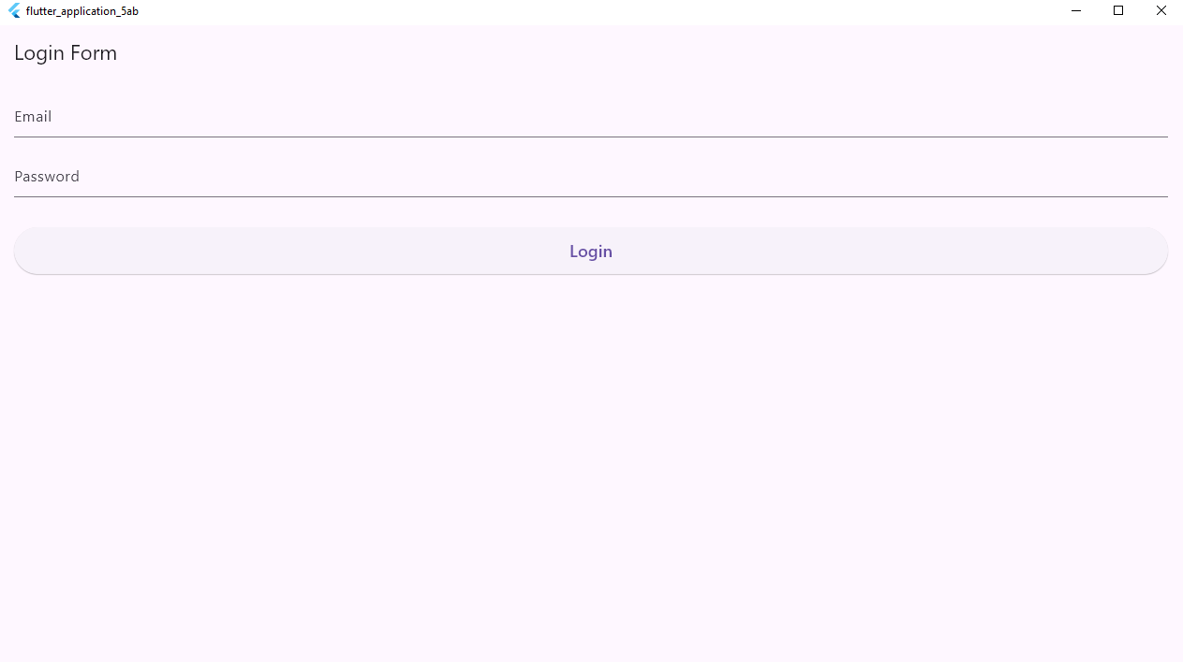
Without entering the data in fields it throws the following error
